NETWORKING-4
Application Layer Management Protocol:
Domain Name System (DNS)
1. Fundamental Purpose & Core Value
Translates human-readable hostnames into machine-readable IP addresses. It acts as the distributed database that powers internet navigation, eliminating the need to memorize numeric or alphanumeric network addresses.
2. Transport Protocol & Port Configurations
- UDP Port 53: Used for standard, lightweight client queries and server responses. Fast but subject to payload size limits.
- TCP Port 53: Used for zone transfers (database replication between primary and secondary DNS servers) and whenever standard query payloads exceed 512 bytes (common with DNSSEC).
3. How DNS Works (The Lookup Process)
When you type a URL into your browser, a multi-step lookup happens in milliseconds:
- Local Cache Check: Your browser and operating system check if they already saved the IP address recently.
- Recursive Resolver: If not found, your device asks a DNS resolver (usually managed by your Internet Service Provider or a public service like 8.8.8.8).
- Root Server (.): The resolver asks a root server, which points the resolver to the correct Top-Level Domain server.
- TLD Server (.com, .org): The TLD server directs the resolver to the specific authoritative name server for that domain.
- Authoritative Server: This server holds the actual IP address record and sends it back down the chain to your browser.
4. Key DNS Components
- Root Servers: The top layer of the DNS hierarchy, split into 13 global identities (A through M).
- TLD Servers: Manages domain extensions like .com, .net, .edu, or country codes like .in.
- Authoritative Servers: The final source of truth that stores the actual DNS records for a specific website.
- Resolvers: Client-facing servers that perform the heavy lifting of tracking down the IP address.

5. Common DNS Record Types
- A Record: Maps a domain name to an IPv4 address.
- AAAA Record: Maps a domain name to an IPv6 address.
- CNAME Record: Creates an alias pointing one domain name to another domain name.
- MX Record: Directs email to the correct mail server for a domain.
- TXT Record: Stores text data used for site verification and email security (SPF/DKIM)
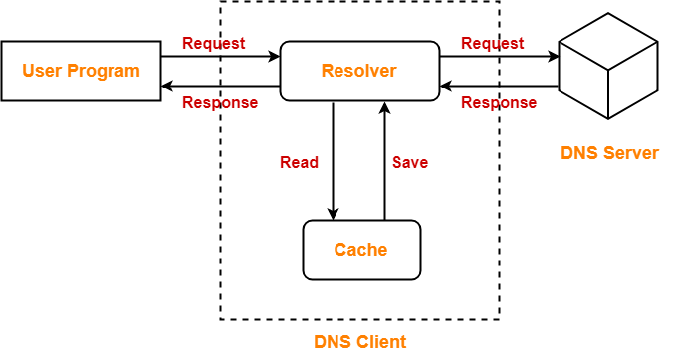
Dynamic Host Configuration Protocol (DHCP)
1. Fundamental Purpose & Core Value
Automates the distribution of network layer configurations (IP addresses, subnets, default gateways, and DNS servers), eliminating manual static typing errors and managing the reuse of IP address pools.
2. Transport Protocol & Port Configurations
- UDP Port 67: Listening port on the DHCP Server.
- UDP Port 68: Listening port on the DHCP Client.
3. Component Architecture
- DHCP Server: The central engine managing the IP address allocation pools (scopes), lease durations, and configuration options.
- DHCP Client: Any network-connected device configured to automatically request network settings.
- DHCP Relay Agent: A utility or router configuration that forwards local client broadcast requests across subnets to a remote DHCP server.
4. Hierarchical Query Process
The sequential exchange relies on the DORA transaction flow:
- Discover: The client broadcasts a layer 3 packet (255.255.255.255) to find any available DHCP servers.
- Offer: Available servers unicast or broadcast a lease proposal containing IP and network configurations.
- Request: The client broadcasts back accepting one specific server's offer, implicitly rejecting others.
- Acknowledge (ACK): The chosen server commits the mapping to its database and finalizes the lease with the client.
5. Essential Record Types
- Scopes: The configured continuous range of valid IP addresses available for lease.
- Exclusions: Specific addresses within a scope omitted from distribution (reserved for static network infrastructure).
- Reservations: Permanent IP assignments bound directly to a device's unique MAC address.
- Lease Time: The specific duration a client can legally use an assigned IP address before needing to renew.
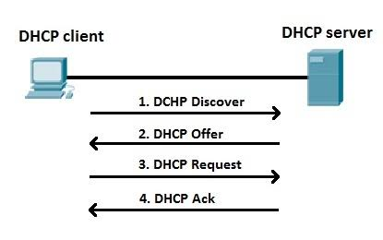
Network Time Protocol (NTP)
1. Fundamental Purpose & Core Value
Synchronizes computer system clocks over variable-latency networks to a precise reference scale. Accurate timekeeping is critical for security log correlation, financial transaction ledger entries, cryptographic authentication protocols, and database replication.
2. Transport Protocol & Port Configurations
- UDP Port 123: Used for all client-to-server and server-to-server time synchronization exchanges.
3. Component Architecture
- NTP Server: A system configured to compute time adjustments and respond to client sync requests.
- NTP Client: Devices querying an upstream host to align their internal system clock.
- Reference Clock: The physical hardware device providing the base time signal (e.g., atomic clocks, GPS receivers).
4. Hierarchical Query Process
NTP is structured around a hierarchical system called Strata:
- Stratum 0: The physical atomic or GPS reference clock itself.
- Stratum 1: Servers directly attached to a Stratum 0 device.
- Stratum 2: Servers that sync with Stratum 1 servers across a network link.
- Clients periodically query upstream servers, calculating round-trip delay and clock offset to smoothly adjust the local system clock (slewing) rather than jumping time abruptly.
5. Essential Record Types
- Offset: The calculated time difference between the client clock and the reference server clock.
- Jitter: The statistical variance in successive delay measurements over the network.
- Drift: The structural rate at which a system's physical internal hardware clock loses or gains accuracy over time.
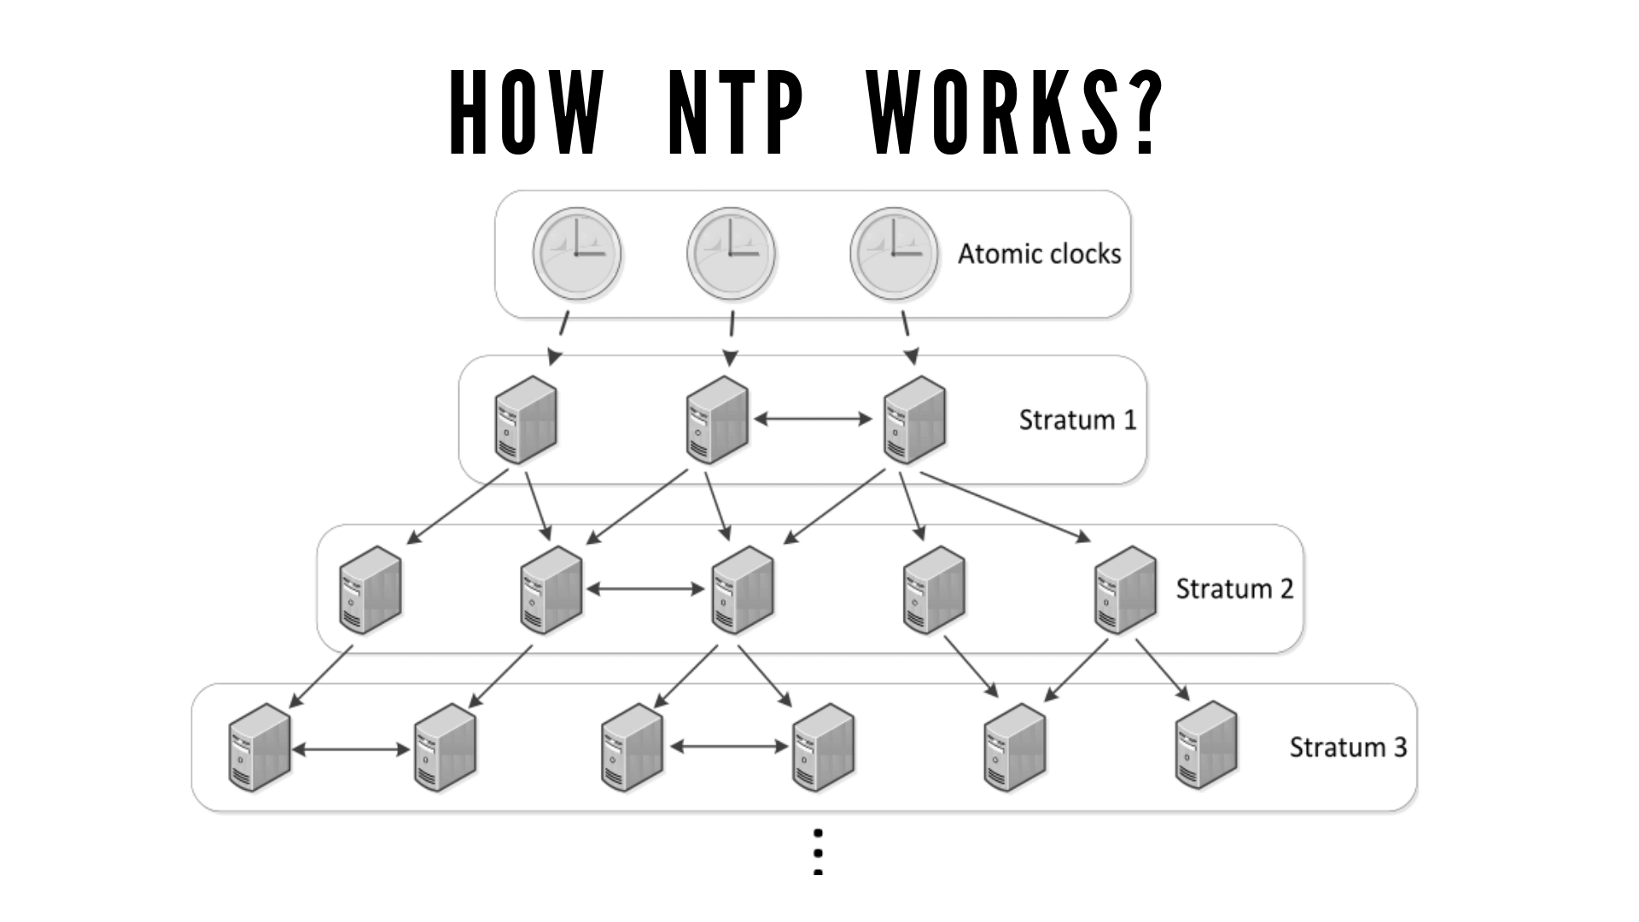
Simple Network Management Protocol (SNMP)
1. Fundamental Purpose & Core Value
Provides an standardized language for monitoring, managing, and configuring network-attached infrastructure (routers, switches, firewalls, servers) from a central interface.
2. Transport Protocol & Port Configurations
- UDP Port 161: Used by the Network Management Station to poll or send commands to the device agent.
- UDP Port 162: Used asynchronously by the device agent to push system warnings or events (Traps/Informs) up to the manager.
3. Component Architecture
- Network Management Station (NMS): The central monitoring console software application.
- Managed Device Agent: The software module running locally inside the network infrastructure component being monitored.
- Management Information Base (MIB): A structured database file defining the operational properties that can be queried or changed on a device.
4. Hierarchical Query Process
- Polling: The NMS sends a GET request for a specific variable. The Agent reads the value from the MIB and sends back a response.
- Traps: When a critical threshold is crossed (e.g., an interface drops or CPU utilization hits 95%), the Agent pushes an unsolicited message to the NMS.
- Walking: The NMS uses GETNEXT or GETBULK commands to discover the structure and fetch arrays of data sequentially.
5. Essential Record Types
- Object Identifier (OID): A dot-separated string of integers defining a hierarchical data point path (e.g., 1.3.6.1.2.1.1.1 points to system description).
- SNMPv1 / v2c: Insecure historical variants that rely on a plaintext security string called a Community String.
- SNMPv3: Modern implementation providing robust cryptographic security through User-based Security Models (USM), offering message integrity, authentication (SHA/MD5), and encryption (AES/DES).
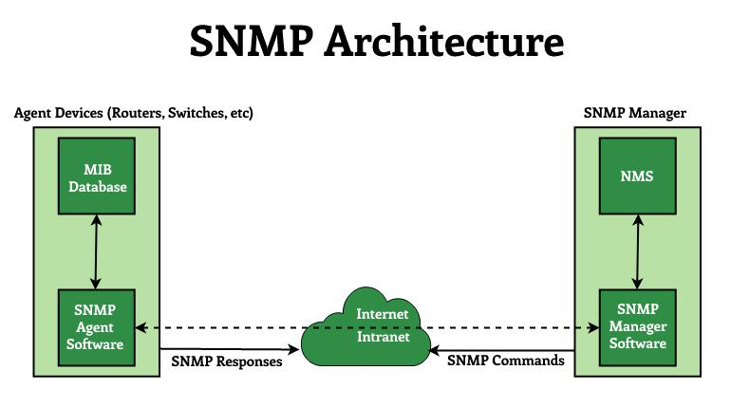
Lightweight Directory Access Protocol (LDAP)
1. Fundamental Purpose & Core Value
Provides a lightweight interface to query, search, and manage a centralized, hierarchical directory services database. It is commonly used for centralized user authentication and corporate address books.
2. Transport Protocol & Port Configurations
- TCP Port 389: Standard connection port for unencrypted or StartTLS-upgraded directory lookups.
3. Component Architecture
- Directory Server (DSA): The database engine storing objects (e.g., Microsoft Active Directory, OpenLDAP).
- Directory Client (DUA): Applications or systems requesting user verification, permission lookups, or object attributes.
4. Hierarchical Query Process
- Connection & Bind: The client connects and performs a "Bind" (authentication) to establish access permissions.
- Search/Modify Request: The client sends a query specifying a base search entry path, scope depth, and filtering parameters.
- Result Delivery: The server returns matching entries or updates the requested fields, then terminates the connection.
5. Essential Record Types
Data is structured hierarchically using distinctive naming schemas:
- DN (Distinguished Name): The unique, unambiguous full path name of an entry (e.g., cn = John Doe, ou = Sales, dc=company, dc = com).
- CN (Common Name): Individual object identifier (e.g., user name or printer model).
- OU (Organizational Unit): Structural folder containers used to group objects logically.
- DC (Domain Component): The parts breaking down the root domain identity.

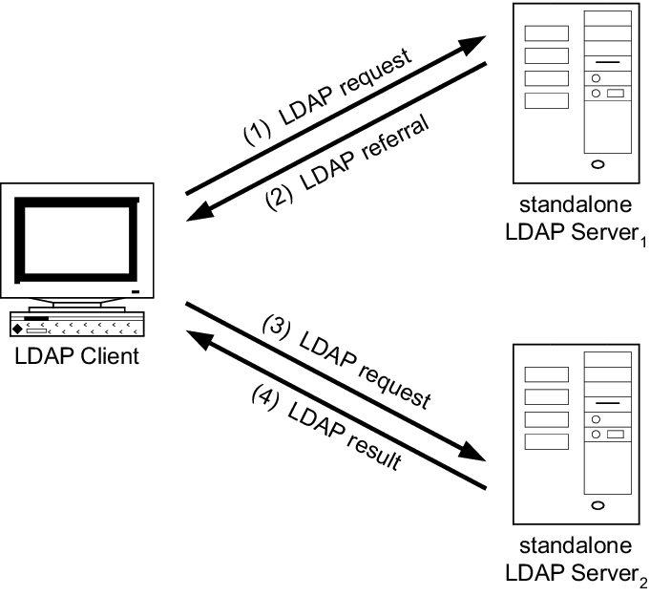
LDAP Secure (LDAPS)
1. Fundamental Purpose & Core Value
Protects directory lookup operations by wrapping the communication channel in Transport Layer Security (TLS/SSL). This prevents the sniffing of cleartext corporate credentials and sensitive directory data over untrusted networks.
2. Transport Protocol & Port Configurations
- TCP Port 636: The dedicated port for raw encrypted directory operations.
3. Component Architecture
- Identical database objects and querying logic as standard LDAP.
- Requires a valid Public Key Infrastructure (PKI) digital certificate installed on the directory server to facilitate encryption handshakes.
4. Hierarchical Query Process
- TCP Handshake: Client initializes basic transport layer link on Port 636.
- TLS Handshake: The client and server perform a cryptographic handshake before any directory protocols are initialized. The server presents its digital certificate for trust validation.
- Encrypted LDAP Session: Once the secure layer is built, traditional LDAP structures and commands are transmitted completely encrypted inside the tunnel.
5. Essential Record Types
- Root CA Certificate: The trusted anchor certificate that the client uses to verify the validity of the directory server's identity certificate.
- StartTLS: An alternative method to LDAPS where a connection begins unencrypted on port 389, then explicitly upgrades to TLS using a specific protocol command, rather than opening a dedicated secure port.

Server Message Block (SMB)
1. Fundamental Purpose & Core Value
Provides shared network access to remote files, directories, printers, and system-to-system communications (Inter-Process Communication). It allows users to open and edit remote files as if they were local storage assets.
2. Transport Protocol & Port Configurations
- TCP Port 445: Modern SMB over IP, running directly on top of the TCP stack without wrapper layers.
- TCP Port 139 / UDP 137 / UDP 138: Legacy configurations running SMB over NetBIOS (NetBT), common in ancient Windows environments.
3. Component Architecture
- SMB Server: The computer containing physical directories, volumes, or printers shared out to the network.
- SMB Client: The user system mapping or accessing those shared folders via a network path.
4. Hierarchical Query Process
- Negotiation: The client and server agree on the highest mutually supported dialect version of SMB.
- Authentication: The client provides user credentials to authenticate against local or domain security accounts.
- Tree Connect: The client requests access to a specific shared folder path (e.g., \\Server\SharedFiles).
- File Operations: The client issues individual open, read, write, lock, and close execution requests.
5. Essential Record Types
- SMBv1: Deprecated, highly vulnerable version (susceptible to exploits like EternalBlue). Uses chatty, inefficient protocol structures.
- SMBv2: A complete redesign that consolidated command structures to reduce network chatter and added support for durable handles.
- SMBv3: Current enterprise standard. Includes advanced features like end-to-end transport encryption, SMB Multichannel (combining network links), and performance optimizations for virtualized storage clusters.
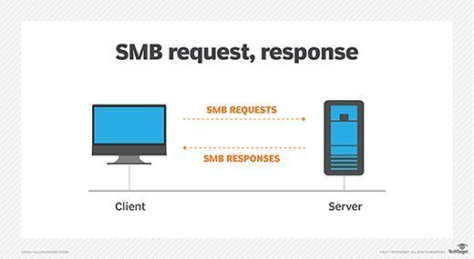

Application Layer Remote Communication Protocols
Telnet (Teletype Network)
- What it does: Provides a basic, text-based terminal interface to a remote computer.
- Port: TCP 23
- How it works: The client and server establish an unencrypted TCP connection. It uses a Network Virtual Terminal (NVT) abstraction so different types of computers can talk to each other uniformly.
- Security Model: Completely Insecure. All data—including usernames, passwords, and commands—is sent across the network in plaintext. Anyone running a simple packet sniffer on the network can steal credentials.
- Modern Use Case: Deprecated for remote management. Today, it is mostly used internally by network engineers to test if a specific port on a remote server is open (e.g., telnet 192.168.1.1 80).
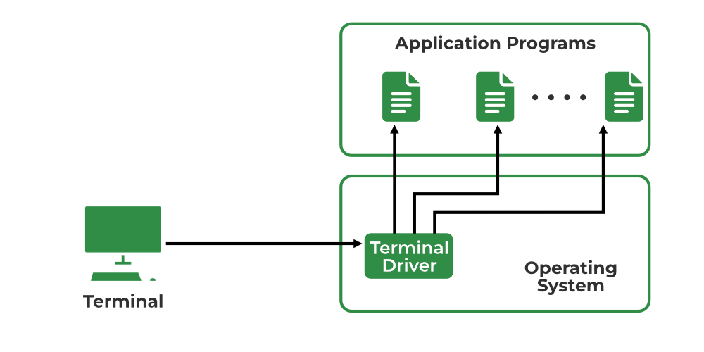
SSH (Secure Shell)
- What it does: Securely connects a client to a remote system's command-line interface. It was designed as a direct, secure replacement for Telnet.
- Port: TCP 22
- How it works: It uses public-key cryptography to build an encrypted tunnel. During connection, the server shares its public key so the client can verify its identity, and they dynamically generate a shared encryption key for the session.
- Key Features:
  - Authentication: Supports traditional passwords, but strongly favors SSH Key Pairs (Asymmetric Cryptography), which are immune to brute-force guessing.
  - Sub-protocols: Powers secure file transfers via SFTP (SSH File Transfer Protocol) and SCP.
  - Tunneling: Can securely forward other network traffic (like web traffic or database ports) through the encrypted SSH tunnel.
- Modern Use Case: The industry standard for managing Linux/Unix servers, cloud infrastructure (AWS, Azure, GCP), and network switches.
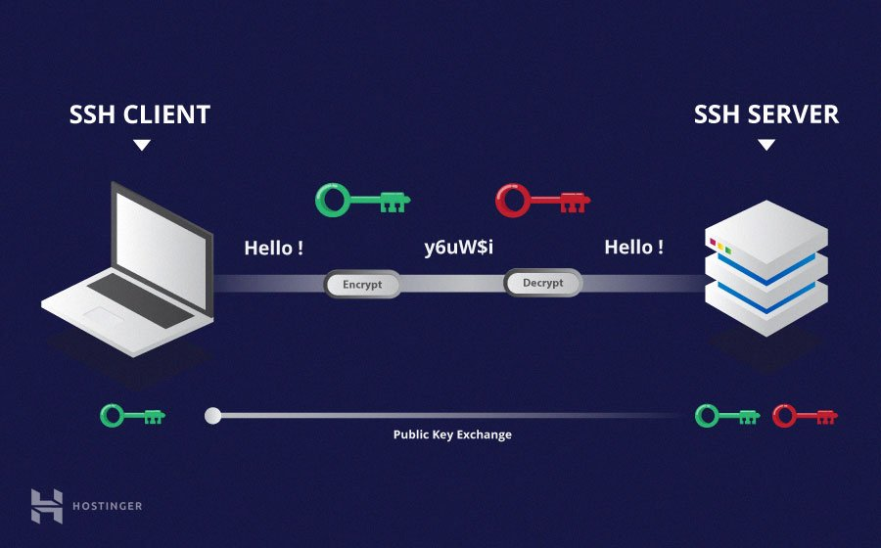
RDP (Remote Desktop Protocol)
- What it does: A Microsoft-proprietary protocol that lets you access and fully control the graphical desktop interface (GUI) of a remote computer.
- Port: TCP 3389 & UDP 3389 (Uses TCP for reliable input/control and UDP for smooth video/audio streaming).
- How it works: Instead of constantly streaming the screen as a giant video file, RDP sends graphical rendering instructions, mouse movements, and keyboard inputs between the client and host.
- Key Features:
  - Network Level Authentication (NLA): A critical security feature that forces the user to log in before the server allocates resources to spin up a full visual desktop session.
  - Resource Redirection: Allows you to map your local printers, clipboard, smart cards, and local hard drives directly into the remote session.
- Modern Use Case: Enterprise Windows desktop administration, remote worker access to office PCs, and helpdesk technical support.
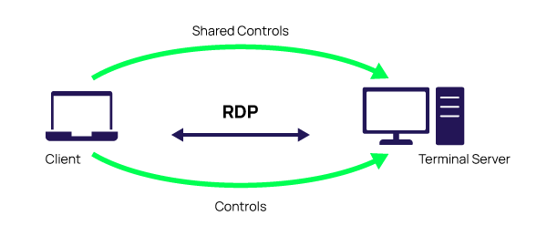
Application Layer File Transfer Protocols
File Transfer Protocol (FTP)
File Transfer Protocol (FTP) is a legacy, out-of-band application layer protocol that relies on TCP to manage file systems over a network. It is architecturally unique because it separates signaling from data payload, utilizing a dual-channel mechanism to execute transactions. The client establishes a persistent control connection to the server on Port 21 to send plain text authentication commands, directory listings, and system instructions. When a file transfer or file enumeration is actually triggered, a separate data channel must be initialized to carry the payload. In Active Mode, the server connects back to a client-specified port from its own Port 20, which is frequently blocked by modern client-side firewalls. In Passive Mode, the client initiates the data connection to a dynamic, random high port provided by the server, forcing server administrators to open wide firewall port ranges. Because FTP passes all control tokens, including passwords and sensitive payload data, across the wire in completely unencrypted clear text, it poses severe security risks and is generally restricted to isolated legacy environments.
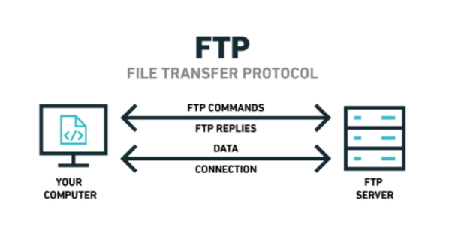

SSH File Transfer Protocol (SFTP)
SSH File Transfer Protocol (SFTP) is a modern, secure protocol designed from the ground up to operate as an extension subsystem of the Secure Shell (SSH-2) suite. Despite its name, it is entirely unrelated to FTP in codebase and design, multiplexing all operations, control commands, and file transfers over a single, secure TCP connection typically hosted on Port 22. Security is established immediately via a robust cryptographic handshake, which negotiates ephemeral session keys for symmetric encryption algorithms like AES or ChaCha20, alongside hashing functions for absolute data integrity. SFTP natively supports secure cryptographic public key authentication, eliminating the need to expose raw passwords in automated scripts or DevOps pipelines. Because all traffic—including commands, directory lookups, and data payloads—is packaged within the encrypted SSH transport frame, it easily traverses network firewalls using a single, highly predictable port, making it the industry standard for production file movements and secure server-to-server data synchronization.

Trivial File Transfer Protocol (TFTP)
Trivial File Transfer Protocol (TFTP) is a stripped-down, connectionless utility built specifically for low-footprint file transport over UDP on Port 69. Designed without any mechanisms for user authentication, directory browsing, or file manipulation, it is built solely to read or write specific files on a remote host. A transfer begins when a client sends a read or write request to Port 69, prompting the server to move the session to an entirely new, dynamically assigned UDP port known as a Transfer Identifier (TID). To compensate for the inherent unreliability of UDP, TFTP implements a strict, application-layer stop-and-wait locking mechanism where data is sent in fixed blocks of 512 bytes. The server or sender stalls after every single block and will not transmit the next segment until it receives a precise confirmation acknowledgment packet from the receiver. Because its implementation footprint is small enough to be embedded directly into physical hardware ROM or firmware chips, TFTP is widely utilized to execute network bootstrapping via PXE boot on diskless workstations, or to safely flash configuration maps and firmware images onto enterprise routers and network switches inside secure local area networks.

Application Layer Email Protocols
Simple Mail Transfer Protocol (SMTP)
Simple Mail Transfer Protocol (SMTP) functions as the primary push protocol used to send and relay outgoing electronic mail across networks. It establishes a connection-oriented communication session over TCP—typically utilizing port 25 for server-to-server relaying, port 587 for secure client submission, or port 465 for legacy implicit SSL/TLS encryption. Operating as a text-based system, SMTP is responsible for transmitting the message from the sender's mail client to the sender's mail server, and then routing it across intermediate mail servers until it reaches the recipient's destination server. Because it is exclusively designed for pushing data, SMTP cannot be used by the -recipient to pull or retrieve messages from a mailbox server.
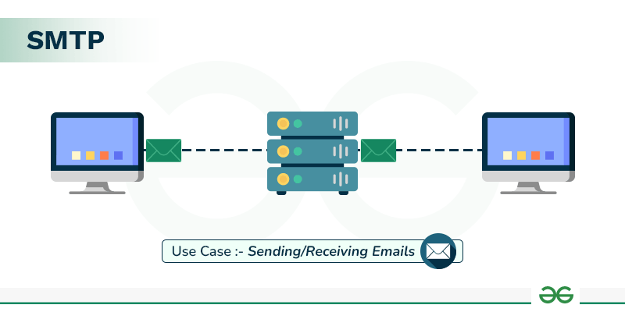
Post Office Protocol Version 3 (POP3)
Post Office Protocol Version 3 (POP3) is a simple, client-side pull protocol designed to retrieve emails from a remote server down to a single local device. It operates over TCP using port 110 for unencrypted connections and port 995 for secure, encrypted connections. Under its standard operating workflow, POP3 connects to the mail server, downloads all available messages to the local hard drive, and immediately deletes the copies from the server. This design makes it ideal for users who need to read messages offline and want to save server storage space, but it makes real-time synchronization across multiple devices, such as phones and laptops, highly difficult.
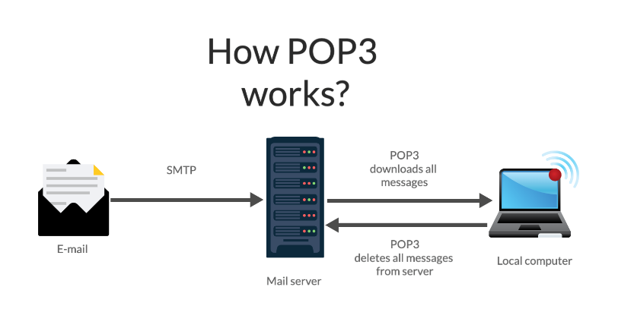
Internet Message Access Protocol (IMAP)
Internet Message Access Protocol (IMAP) is an advanced, multi-device pull protocol that allows users to access, organize, and manage their email directly on a remote server. It standardly operates over TCP port 143, or port 993 when secured with SSL/TLS encryption. Unlike POP3, IMAP leaves the master copies of the messages on the server and only downloads temporary cached copies to the local device. This architecture enables seamless, real-time synchronization, ensuring that any actions taken by a user—such as creating folders, marking a message as read, or deleting an email—are instantly reflected across all connected devices simultaneously.

Application Layer Web Browser Protocols
The Application Layer serves as the direct interface between network services and user applications, such as web browsers, enabling the standard formatting and exchange of data across the internet. Within this layer, web browsers rely primarily on specialized protocols to request, retrieve, and render web pages securely and efficiently.
- Hypertext Transfer Protocol (HTTP): This is the foundational protocol of the World Wide Web, operating as a stateless, client-server request-response protocol used to transmit hypertext documents like HTML. When a user enters a URL, the web browser acts as the client, sending an HTTP request to the target server, which then responds with the requested resources (such as text, images, and scripts). Because standard HTTP transmits data in plain text without encryption, it is highly susceptible to interception, eavesdropping, and tampering, making it unsuitable for exchanging sensitive information like passwords or credit card numbers.
- HTTP Secure (HTTPS): This protocol is the advanced, encrypted extension of HTTP that secures communication over a computer network by layering the standard protocol on top of the Transport Layer Security (TLS) or older Secure Sockets Layer (SSL) encryption protocols. HTTPS establishes a secure, encrypted tunnel between the web browser and the server, ensuring data confidentiality through encryption, data integrity by preventing unauthorized modifications during transit, and authentication via digital certificates. In modern web browsing, HTTPS has become the baseline standard required by web browsers to protect user privacy, secure sensitive transactions, and verify the legitimate identity of websites.



